**SDA LAB 9**

**K201052**

**BSE-4B**

Task 1a



Task 1b



Task 2

Sequence Diagram

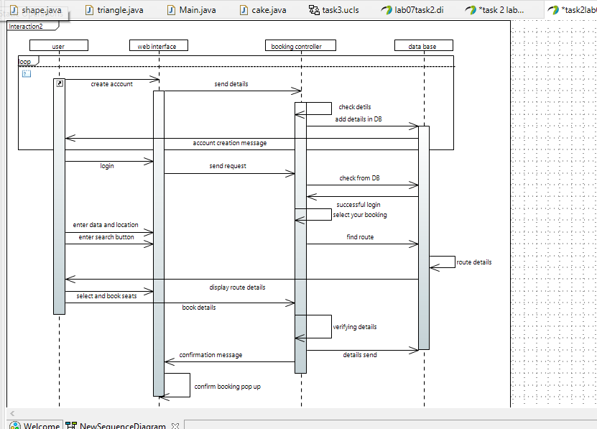

Task 3

System Sequence Diagram

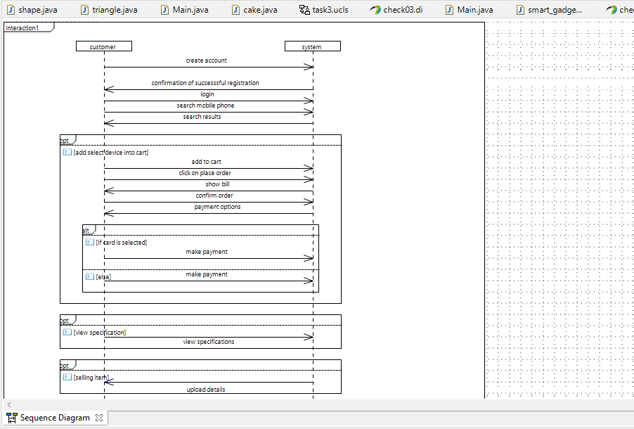

Task 4

Collaboration Diagram

